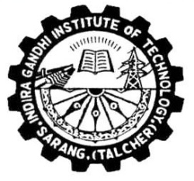

**INDIRA GANDHI INSTITUTE OF TECHNOLOGY**

**SARANG**

***Certificate***

**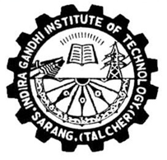***This is to certify that this project entitled “****Object Classification in Multiple Languages****” submitted by* ***Anshuman Sekhar Dash (****1501105478****),Pruthiraj Marndi (****1501105496****), Swagat Dora (****1501105509****) and Sanjay Tudu (****1501105501****)*** *of Computer Science, Engineering & Applications Department, Indira Gandhi Institute of Technology, Sarang for the partial fulfillment of the requirements for the award of Bachelor of Technology (Computer Science & Engineering) Degree of BPUT, Odisha, is a record of students own study carried under our supervision & guidance.*

*This report has not been submitted to any other university or institution for the award of any degree.*

*Date:6th April 2019*

|  |  |
| --- | --- |
| ***D.K Swain,***  ***1st Guide***  ***S.K Patra:,***  ***2nd Guide*** | ***(Dr. S. N. Mishra)***  ***Professor & Head,***  ***Dept. of CSEA, IGIT, Sarang***  ***Dhenkanal, Odisha***  ***Signature of***  ***External Examiner*** |